Dear VMC Families,
January 6th, 2022 Day 2 will be our first day of classes and we are looking forward to seeing our students online over the next few days. Your child's MS Teams calendar should already be populated with this week's classes. All they need to get started is their EMSB email and password.
Quick reminder - As the MEQ has directed all students to return to school online this week, if your child must be absent, please continue to report absences through Mozaik or to the main office. Attendance is compulsory for all EMSB students as of January 6th, 2022 and teachers will be taking attendance each period. If your child is absent due to Covid-19 or if your child tests positive but continues to report to classes, please advise the school.
Although we are online, if your child is unwell, they do not need to attend online classes. Use your judgement and apply the absence protocol. If a student feels unwell during class they must advise their teacher prior to leaving the classroom by messaging the teacher through MS Teams.
To our students:
Starting January 6th, VMC online classes will begin through Microsoft Teams. Regular attendance is expected and parents will be advised of absences. If you need to leave class for any reason you must advise the teacher. Microsoft Teams is accessible through your EMSB assigned email. Your MS Teams calendar will be populated with your classes. To minimize issues, please complete the following checklist:
1. Use Chrome as your browser. Chrome allows you to access all the features of this tool.
2. Do not use Gmail to access your EMSB email because it will be refused.
3. Make sure you are accessing the e-portal (located at the bottom of the web page) through the EMSB home page or access it through www.webmail.emsb.qc.ca .
3. Once you sign in, you will find Microsoft TEAMS in the waffle (top left-hand corner). Or download the app on any smart device - it's easy.
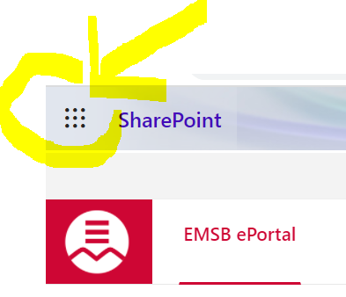
Use the short videos below to help familiarize yourselves with MS Teams:
https://youtu.be/qx8xHpRMFHU - Signing into MS Teams for the first time as a student
https://youtu.be/PasT3Q1ZR_I - Connecting with MS Teams as a student
https://youtu.be/5yT1K34RJo4 - Working with classes and classmates on Ms Teams
https://youtu.be/knOp1wT84x8 - Organize schoolwork with MS Teams
We hope this information is useful and answers some of your questions. Your teachers will be able to assist you online. You will be following your regular school timetable and using the netiquette model. Put on your VMC top and sit at a table or desk with the tools you need to take notes and be organized. Keep your regular school morning routine without leaving home. This will help you be alert and ready to learn during class time.
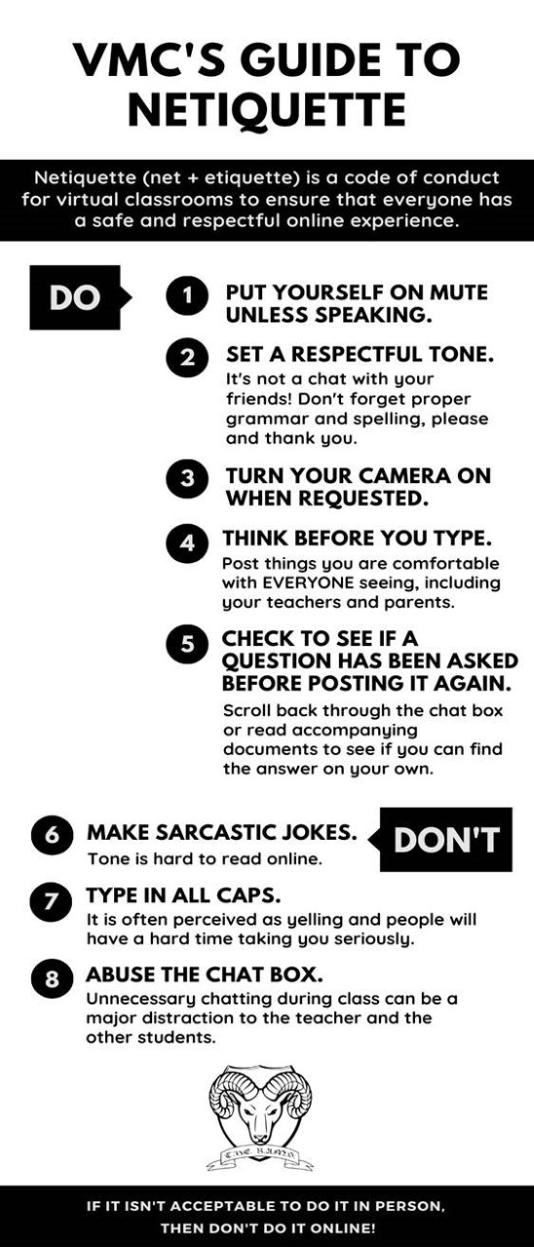
We should be back to in-person classes on January 17th, 2022. If there are any changes you will be advised by school messenger and through MS Teams.
If you have access issues or questions, please contact:
Sec 1 & 2: Ms. Di Sorbo at cdisorbo@emsb.qc.ca
Sec 3 & 4: Ms. Fanelli at gfanelli@emsb.qc.ca
Sec 5: Ms. Cristiano at fcristiano@emsb.qc.ca

Sincerest Regards,
Franca Cristiano
Principal

