Hi VMC!
It's that time of year. Show someone you care through the gifting of a bear ;)
Just follow the link below....
https://forms.gle/x1Y3WKiXZd3HfyNS9
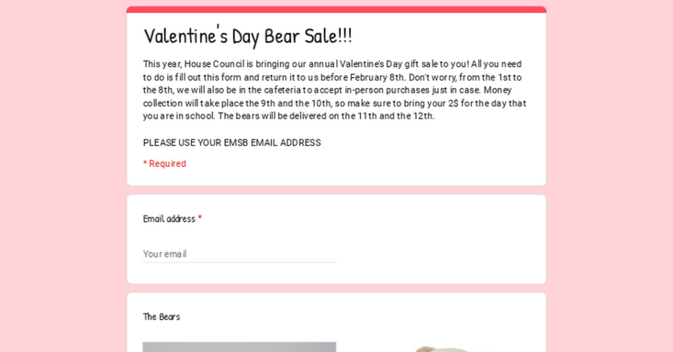 | Valentine's Day Bear Sale!!!!  This year, House Council is bringing our annual Valentine's Day gift sale to you! All you need to do is fill out this form and return it to us before February 8th. The bears will be delivered on the 11th and the 12th, so make sure to bring your 2$ then. Don't worry, we will also be in the cafeteria to accept in-person purchases just in case. PLEASE USE YOUR EMSB EMAIL ADDRESS  forms.gle

Best regards,
House Council

