Dear parents,
VMC's H.I.V.E club is finally selling honey since the pandemic! We are selling on the 13th and 14th of February (both lunches) right on time for Valentine's day!
Please place your order using the google forms link below.
This is our exclusive VMC honey produced from our very own beehives on the third floor - taste the difference and support our bees!
See you at the sale!
H.I.V.E club

https://forms.gle/UaSa4jQdCzxPf9Yj8
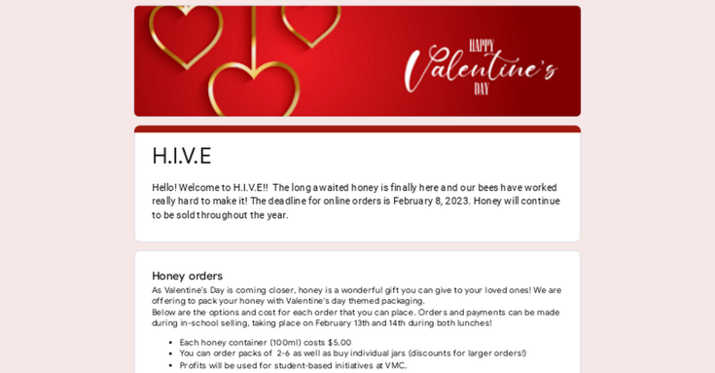 | H.I.V.E  Hello! Welcome to H.I.V.E!! The long awaited honey is finally here and our bees have worked really hard to make it! The deadline for online orders is February 8, 2023. Honey will continue to be sold throughout the year.  forms.gle

