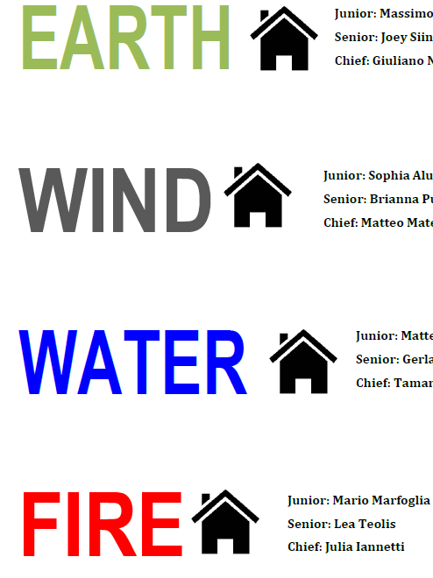
Junior: Thivikan Selvarajah
Senior: Luca Tangredi
Chief: Alexander Yee
Junior: Anthony Purchio
Senior: Liana Di Fonzo
Chief: Anna-Lisa Cavallaro
Junior: Giuseppe Di Sano
Senior: Matteo Rossi
Chief: Emanuela Greco
Junior: Matthew Cortez
Senior: Gabriella Argento
Chief: Matthew Vitali
NOM DE
VOTRE ÉCOLE

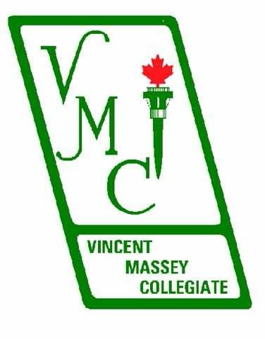

5925, 27th Avenue
Montreal, Quebec
H1T 3J5

www.vmc.qc.ca

Property of

NAME:

HOMEROOM:

August 2022

Dear Students,

Welcome to Vincent Massey Collegiate. The school agenda provides you and your parents with information that will help you to be successful at Vincent Massey Collegiate. This agenda should become an integral part of your daily studies.
The student handbook outlines the policies, procedures, and routines of VMC. It clearly specifies our expectations of you. The rules and regulations contained herein reflect the philosophy that we at Vincent Massey Collegiate are committed to maximizing the intellectual, moral, and physical development of each of our students.
Vincent Massey Collegiate’s positive environment is contingent upon respect – respect for oneself, respect for others, and respect for one’s environment. We trust that we will all work to maintain this positive school philosophy. We extend our sincerest wishes for your continued success.

Respectfully,

Franca Cristiano | Chantal Juhasz | Vince Timpano
Principal | Vice-Principal | Vice-Principal

Vincent Massey Collegiate
Leadership, Scholarship and Self-reliance

Tel: (514) 374-1999 www.vmc.qc.ca Fax: (514) 374-1659

PHILOSOPHY AND MISSION STATEMENT
Vincent Massey Collegiate is committed to promoting academic excellence within an enriched and structured CEGEP preparatory program. As one of a variety of schools within its public educational system, the English Montreal School Board recognizes the diversity of the students it serves. Vincent Massey Collegiate is dedicated to responding to the needs of the above-average student and to the expectations of their parents.

The primary mission of the Collegiate is to develop well-rounded students who are committed to academic achievement and who have a sense of community responsibility. This mission will be fulfilled through the Collegiate’s Educational Project based on English educational traditions and values. It will be accomplished through strong emphasis on academic excellence and self-discipline, as well as obligatory participation in a diversified range of school activities, and this within a committed partnership-oriented educational community.

This school community realizes that pursuing the Collegiate’s mission requires not only a high level of personal commitment from students but also the commitment, dedication, and participation of teachers, parents, and administrators in order to maintain and implement the school’s academic, curricular, and behavioral standards. It is the combination of these components and related characteristics, which create Vincent Massey Collegiate’s unique, distinct, and unequalled learning environment.

TERRITORIAL ACKNOWLEDGEMENT
We would like to acknowledge that Vincent Massey Collegiate is located on unceded Indigenous lands. The Kanien’kehá:ka Nation is recognized as the custodians of the lands and waters on which we gather today.

Tiohtià:ke/Montréal is historically known as a gathering place for many First Nations. Today, it is home to a diverse population of Indigenous and other peoples. We respect the continued connections with the past, present and future in our ongoing relationships with Indigenous and other peoples within the Montreal community.

ACADEMIC STANDARD
An entrance examination, with an admission standard, will be required of all students seeking admittance. This result, along with an evaluation of previous academic performance, will constitute the basis for the admission decision.

Students are required to maintain high academic standing during their time at Vincent Massey Collegiate. Every student's academic record will be reviewed regularly. Students will be removed from the Collegiate if either criterion is not met:

- A student must maintain an overall weighted average of at least 65% on their June results (attestation of marks).

- A student must pass each of the following prerequisite courses: Mathematics, English and French. Secondary 4 students also must pass History and Science & Technology.

Students in danger of not meeting these standards will be on probation.

CURRICULAR STANDARDS

- A specific emphasis on Mathematics and Science will be a core aspect

- Enrichment will be offered in all subject areas

- French enrichment at all levels

- CIT (Communication and Information Technologies) will be incorporated into all subject area methodology

- A system of teacher-directed tutorials will be offered

- A homework policy will be in effect at all levels

- Participation in at least one school/community activity will be obligatory

- Participation in a 30-hour Community Service Program

PROBATION
A student who obtains an overall average of less than 70% for a term may be placed on probation. A student is expected to improve their marks in order to be removed from probation. A student who is on probation may:

- Lose the right to attend major field trips.

- Be placed on an academic tracer.

*Students who demonstrate, via the academic tracer, improved effort, and results, on a weekly basis, will be permitted to participate in extra-curricular activities*

ADHERENCE TO STANDARDS
Upon admission, parents and students will be required to indicate, in writing, their commitment to the Philosophy and Mission Statement of Vincent Massey Collegiate, and their acceptance of its standards and regulations. Failure to adhere to this agreement could lead to the student being required to withdraw from the school.

PLAGIARISM
Definition: Plagiarism is the use of someone else’s words, works, or ideas without giving the person credit (please see MLA, APA for a thorough definition). Plagiarism is a very serious infraction, and has led to failure in subjects, expulsion from programs, and even expulsion from colleges, and/or universities in some situations.

At Vincent Massey Collegiate, we consider plagiarism to be a serious offence, and any student caught plagiarizing (MLA, APA) is subject to receiving a zero for that assignment, accompanied by a letter of reprimand which will be placed in the student’s file and remain there for the duration of his/her studies at Vincent Massey Collegiate.

A student who hands in a major assignment (usually equivalent to greater than 10% of the term mark) shall vouch for the authenticity of his/her work by completing the following form:

STATEMENT OF AUTHENTICITY

Name: Homeroom: Course:

Name of Teacher:

- I have written this assignment by myself.

- This assignment consists entirely of my own ideas, observations, references, information, and conclusions, except for statements contained within parentheses, which have been attributed to the proper source.

- All the sources that I have consulted and/or included in this assignment have been listed in the Reference section of this assignment

I am aware that PLAGIARISM (MLA, APA) is a serious infraction, and I have NOT plagiarized this assignment.

NAME: DATE:

SIGNATURE:

SECONDARY SCHOOL DIPLOMA
In order to qualify for graduation with the right to follow collegiate level studies, students must meet the following conditions:
- Pass the following compulsory subjects:
  - 4 credits in Secondary IV History and Citizenship Education
  - 4 credits in Secondary IV Science and Technology
  - 6 credits in English Language Arts Secondary V
  - 4 credits in French Secondary V
  - 4 credits in Secondary IV Math (completed in sec 3)
  - 2 credits in Secondary IV Arts Education
  - 2 credits in Secondary V ERC or PE

- Accumulate 54 credits at the Secondary IV and V levels with at least 20 of these credits recognized at the Secondary V level.

HONOUR ROLL

Each term the names of many of our students appear on the School’s Honour Roll (Honours) for attaining an average of 80% or higher. Students who attain an average of 85% or higher will be recognized on the Honour Roll (High Honours). Students who attain an average of 90% or higher will be recognized on the Honour Roll (Highest Honours).
Honours (cum laude) 80%
High Honours (magna cum laude) 85% Highest Honours (summa cum laude) 90%

EVALUATION POLICY
- Mid-Terms and Finals

- All midterms will be worth 50% of Term 2 (non-moderated courses only). Where the student scores higher on the midterm exam, and their name has not been submitted to administration for handing in assignments late, the midterm will count for 100% of Term 2.

- All finals will be worth 50% of the year (non-moderated courses only). Where the student scores higher on the final exam, and their name has not been submitted to administration for handing in assignments late, the final exam will count for 100% of the year.

- Students flagged for academic review by administration may lose the right to benefit from this policy.

- When the Ministère uses moderation, it compares, for each class, the school marks and the ministerial examination marks. Moderation involves adjusting each student’s school mark upward or downward. It cannot, however, result in the failure of any student who has obtained a pass mark on the uniform examination.

Late Assignment Policy

- A student who submits a major assignment ONE day late (after 4 pm on the due date) will be deducted 10% and parents will be contacted. The maximum mark that can be obtained will be a 90%.

- A student who submits a major assignment a SECOND day late (after 4 pm on the due date) will be deducted 10%, parents will be contacted a second time, and administration will be notified. The maximum mark that can be obtained will be an 80%.

- A student who submits a major assignment a THIRD day late (after 4 pm on the due date) will be deducted 10%, and administration will be notified. The student will then serve a detention every day after school until the assignment has been submitted. The maximum mark that can be obtained will be a 70%.

- When handed in on the FOURTH day, the maximum mark that can be obtained will be a 60%.

EXAMINATIONS

Mid-terms & final exams take place in December and April to June, respectively. Supplemental MEES exams take place in January.

During examination sessions, students must be present for the times and dates indicated for each of their exams. Failure to do so will result in a mark of zero being assigned. An exception to this policy will only be made in cases of verifiable family crisis or upon presentation of a medical certificate deeming the student unfit to write the examination.

In addition, students who miss class exams administered by their subject teachers may be required to submit a medical certificate deeming them unfit to write the examination

EXAM ROOM
In order to be admitted into the exam room, students must:

- Show their VMC ID card;

- Be dressed in uniform (in conformity with the current dress code), shoes included;

- Transport all their materials in a transparent bag (pencil cases are not allowed);

- Bring only materials required for the exam; Teachers will advise students prior to the beginning of the exam period; if applicable: return course textbooks or any loaned materials;

- Arrive in the first 30 minutes of the exam.

Students cannot enter the exam room with:
- Any schoolbag, purse, etc.
- Any electronic devices such as: phones, iPods, smart watches, earbuds, etc. In accordance with Ministry directives and school policy, any student in possession of these items, once the exam begins, will be considered cheating.
- Students will have access to their lockers only until the last day of regular classes.

VACATIONS

No accommodations will be made for students going on vacation during the school year. It is the responsibility of students and parents to schedule holidays outside of the academic calendar. For any extenuating circumstances, please contact the administration.

HOMEWORK

Homework is a necessary part of a student’s daily routine.

At the junior high level:
- Secondary I and II students at VMC should spend up to 1½ hours per school day on homework. This implies an average of 15 minutes per day for each course the student follows.

At the senior high level:
- Secondary III, IV, and V students should be prepared to spend up to 2 ½ hours per school day on homework. This implies an average of 25 minutes per day for each course the student follows. Students who are following a number of enriched courses at the secondary IV and V levels should expect to spend up to three hours per night on homework.

- It should be noted that homework is not only written assignments. Reading, reviewing, and studying are an important part of homework.

- Students should be reviewing the material covered in each subject on a regular basis in order to be prepared for examinations.

- Students should not wait until the last minute to commence working on long-term assignments but should work on them gradually over the period of time that has been allotted.

- Students are responsible for all material covered and assignments given during their absence.

TUTORIALS
Tutorial instruction is offered to Vincent Massey Collegiate students requiring extra help in certain subjects. Tutorials take place outside of the regular timetable. Parents may request that their child attend tutorials, but it is their child’s responsibility to attend. The administration may mandate students to attend tutorials if they are at-risk of failing.

For further information, you can consult with the school administration, teachers, or the guidance counsellor.

LIBRARY

The library is open before school, at recess, during lunch, and after school. The following rules must be adhered to when using the library:

- The library is a quiet workspace. Volume must remain low. Students who disrupt the space with noise will be asked to leave.

- Students may not enter the library wearing coats or boots. Uniform rules must be respected at all times.

- Students are prohibited from eating and drinking, including water, in the library. Anyone caught eating/drinking will be asked to leave.

- Students using the library during class time must have a note from their teacher.

- Students using the library must be carrying their Student ID cards.

- Desktop computers are reserved for schoolwork and printing only.

- All printing is $0.10 cents per page.

- Students may borrow up to 4 books at a time. The loan period is 3 weeks with the possibility of renewals. Late returns are charged $0.10 cents per book a day, excluding weekends and Holidays, for a maximum of $5.00 per book.

- When the library is at capacity students will not be permitted to enter.

The following rules must be respected when using Library Chromebooks:

- Students must present their Student ID to the Library Technician in order to use a Chromebook. All Chromebooks must be scanned out in the Library system prior to use.

- Chromebooks are to be used solely for educational purposes.

- Students must return their Chromebooks to the Library Technician.

- As per the agreement in the student agenda, “Students who either damage computers or enter sites that are not “suitable” for educational purposes are subject to losing their computer privileges for the year.”

Using the library is a privilege. Students who do not obey the rules or who act disrespectfully to each other, to the library property or to the library staff will be asked to leave and may be subject to further disciplinary actions. Repeat offences will be subject to further disciplinary action. Students are expected to do their part in keeping the library clean, quiet and safe.

If a book is lost, stolen, or damaged, the borrower is responsible for the cost of replacing the book.

BEHAVIOURAL STANDARDS
- Students will be required to adhere to a code of behavioral standards.
- Students will be required to be respectful on and off school grounds. This means carrying oneself with maturity and integrity within the community.

RULES OF CONDUCT AND SAFETY MEASURES
As a student of the Collegiate, you have the right to learn. No student should disrupt the learning environment. Teachers and administration will hold students responsible for their conduct while in school and while participating in school activities.

“Respect for ourselves guides our morals, respect for others guides our manners.” Laurence Sterne

DISCIPLINARY ACTION
Students who break school rules or do not conform to school policies are subject to a variety of disciplinary sanctions, which include:
- Recess and lunchtimes spent at the office for a period of time
- Extra work assignments
- Detention after-school
- In-school suspension
- Suspension from school
- Transfer or expulsion

SUSPENSION FROM SCHOOL
Students who develop a chronic pattern of breaking school regulations run the risk of being suspended from school. Any student who commits a serious infraction (e.g., possession of drugs, weapons – pocket knives, knives, guns, etc. – vape paraphernalia or alcohol, bullying, misuse of social media & technology, fighting - either in school or travelling to/from school - vandalism, insubordination, truancy, skipping detention, etc.) will be suspended without prior warning.
When a student is suspended from school, one of his/her parents or guardians will be required to come to school to discuss the terms of his/her re-admittance.

VANDALISM
All students at Vincent Massey Collegiate are expected to take proper care of school property. Parents are held financially responsible for damages resulting from carelessness or vandalism caused by their children. This includes:

- Damage to teaching materials including books, Physical Education equipment, lab, uniforms, audio-visual equipment.
- Damage or defacement of desks, lockers, walls, cafeteria tables, or any other school property.
- Damage to staff and student property.

Also, students may not use school items that do not belong to them without authorization. Damage to property may result in suspension until the student or his/her parents have paid for the damages.

PROHIBITED SUBSTANCES FOR MINORS
The students and staff of Vincent Massey Collegiate are entitled to a safe environment. It is prohibited for anyone to use drugs, smoke tobacco or vape on school grounds. Students are forbidden from using, consuming and/or selling tobacco products, vape products, alcohol, marijuana and any illegal substance. The use of such substances, on or off school grounds, during school hours, during extra-curricular activities and/or school trips is strictly prohibited and results in severe consequences. Selling of any of the above may result in expulsion from the Collegiate.

GAMBLING
Students are prohibited from gambling at any time at school or when involved in a school related activity. Gambling consists of playing a game in which players can win or lose money or possessions.

NEIGHBOURHOOD RELATIONS
It is important that the school maintain a good relationship with the residents and business people in the area. To this end, we request that students treat our neighbors with respect and that they do not congregate in or around business establishments and alleys.

DETENTION SYSTEM
Detentions are served after school. Students receive detentions for lates, uniform infractions, name calling, use of inappropriate language, including racial, homophobic, and transphobic slurs, and any other behavior that is deemed disrespectful. All students will be given two chances per semester for morning lates. These chances can be used when students are late without medical justification. Proof of medical justification will be requested. It should be noted that lateness due to traffic or weather is covered by this chance system.
Accumulated Late Arrival:
If a student is consistently late during a semester, they will serve a detention on the third and each subsequent infraction. On the 4th served detention, which is the 6th infraction, the student will be issued an in-school suspension. Each subsequent detention within the semester will result in an in-school suspension. Chances will be reset for all students at the beginning of the 2nd semester.

BULLYING
Students must treat every staff member and their peers politely and respectfully at all times. They must avoid name-calling, threats (including cyber-bullying – via electronic medium such as social media sites or cell phones) and physical as well as psychological intimidation. These actions will result in consequences ranging from detention to suspension from school. Bullying is a specific relationship characterized by recurrent abuse of power by a person or group over another person, with the intent to hurt, oppress, intimidate, or ostracize.

If you are a target of bullying, report the incident to an adult in the building. All bystanders have a social responsibility to report acts of bullying to an adult in the building. Failure to report incidents may result in disciplinary action. All incidents of bullying must ultimately be reported to the administration to investigate, mediate, and discipline. Perpetrators will face serious disciplinary action including, but not limited to, mediation, suspension, and possible transfer to another school.

T.H.E. R.A.M.S. Pledge

I believe that everyone at Vincent Massey Collegiate has the right to be part of an accepting school environment. I will empower others by taking a stand against bullying.  I pledge to promote inclusion, appreciation, and respect for all.  I think…  To  Help  Everyone  Raising  Awareness  Makes  Sense | Je crois que tout le monde à Vincent Massey Collegiate a le droit de faire partie d’un environnement scolaire accueillant. J’encouragerai les autres à faire face à l’intimidation.  Je m’engage à promouvoir l’inclusion, l’acceptation et le respect pour tous.  Soyons…  Tous  Heureux  Ensemble  Réunis  Autour d’un  Monde  Solidaire

TEXTBOOKS
The subject teacher will distribute the textbooks required for each course. Once the courses have been completed, students are expected to return all books to the school in relatively the same condition in which they were received. Failure to do so shall result in students being charged for book replacements.
If a library book is lost, damaged, or stolen, the student will be charged for the replacement. When a library book or a new textbook has been lost or damaged, the student must pay the full price of the book. In the case of a damaged or lost textbook that has been used by others in previous years, part of the price of the book will be collected from the student.

LOCKERS
The day 1, period 1 teacher will assign each student his/her own locker, which will be shared with another student. Each student will be assigned a school lock and the locker must be kept locked at all times.

- A combination lock will be issued for each locker.

- Lockers must be kept tidy and free of objectionable materials.

- Never leave valuables in your locker.

- Lockers and locks are loaned to the students for the year.

- It is forbidden to occupy a locker other than the one you have been assigned.

- Lockers are subject to search by the administration.

- Students must have an extra lock for physical education class. Personal belongings should be locked in the changing room lockers during each Physical Education class. Locks must be removed at the end of the P.E. period.

- All locks must be returned prior to the examination period in June.

- Lockers that are left open before, during and after school will be bolted for safety/security purposes.

- School locks must be returned by the last day of classes. Lost locks will cost $7.00 each.

Students and parents are advised that expensive articles such as cell phones, laptops, Air Pods, etc. should not be brought to school, as the school cannot guarantee the security of its lockers.

Please note the school is not responsible for lost or stolen articles.

UNIFORM
Students are expected to attend school and respect the VMC School Uniform policy. The policy includes cleanliness, proper grooming, and the wearing of the school uniform without modifications.

VMC students must arrive and depart from school wearing the uniform according to the following requirements:
  - All students must wear a white VMC monogrammed top (polo, turtle neck or shirt); VMC sweaters must be worn with a VMC top.

  - Students must wear the official navy slacks, Bermuda shorts or skirt (also available in plaid). Skirts are not to be hemmed or rolled at the waist.

  - Skirts must be approximately 2.5 inches above the knee.

  - All students must wear solid (no stripes) black shoes (no boots, high tops, or booties).

  - Students must wear solid navy blue, black, dark green or dark grey socks. Socks must be below the knee and all hosiery must have feet (included tights with feet). No leggings.

  - Any garment worn under the regulation white top must be plain white and without writing. House shirts may not be worn under uniform shirts. Any garment worn under the VMC top must not be visible at the arms or waist.

  - Belts must be black or blue and must be worn through the belt loops. Decorative belts are not permitted.

Uniforms are not to be altered in any way. VMC students are not permitted to wear:

    - Shoes with a platform higher than one inch.
    - Sweaters other than regulation VMC sweaters sold at TOP MARKS.
    - Headgear, boots, or outdoor wear in the building.

TOP MARKS:
5760 Ferrier St. Mount Royal Quebec H4P 1M7 514 344-5454

Students who are not properly dressed for school will be sent home to change (this includes examination sessions). They will be required to make up lost time in detention. The regulation uniform will be strictly enforced.

PHYSICAL EDUCATION UNIFORMS
A uniform is compulsory for all students following Physical Education courses at Vincent Massey Collegiate. Shorts, joggers, and t-shirts are available through TOP MARKS, our official school uniform supplier. Running shoes must be worn in the gymnasium. All other shoes, which may mark the gym floor, are not permitted.

Students who are not in the proper gym uniform for Physical Education classes will be issued a detention by the teacher.

WORKBOOKS
There are courses that require the purchase of workbooks. At the beginning of the school year, students will receive workbook fees by level.

21st CENTURY CLASSROOM
VMC believes that access to the tools and resources from the worldwide network and the understanding of when and how these tools are appropriately and effectively used is essential to every student’s education. However, the use of technology to access educational material is not a necessity but a privilege. This access will benefit the learning environment. When the rules are abused, privileges will be taken away. Students bringing their own device to school must adhere to the Student Code of Conduct as well as to the English Montreal School Board’s policies, particularly Internet Acceptable Use and Internet Safety.

Instances of probable inappropriate use may be investigated. The EMSB encourages all schools to act discreetly and in a confidential manner in conducting such investigations.

ELECTRONIC/SMART DEVICES
The English Montreal School Board supports Bring Your Own Device, BYOD. Students are permitted to use iPods, Air Pods or similar, cell phones, smart watches or cameras in class at the discretion of the teacher. This will be determined on a class-by-class basis. If a student does not follow the teacher’s rules, they will confiscate the device and submit it to administration. Administration will record the infraction. For the first offence, the device will be returned at the end of the day. For the second, and all subsequent infractions, parents will have to schedule an appointment to discuss the issue and collect the device. Students are forbidden to photograph or record any student or adult without their permission. Students are not to use portable speakers in the school. A reminder that all electronics are prohibited during all exams and violators will be considered cheating if any device is found in their possession.

COMPUTER USAGE
Students will have access to a number of computers and tablets in the school. These devices are connected to the Internet. Certain sites are impossible to enter because of a “blocking” program. Students who either damage computers or enter sites that are “unsuitable” for educational purposes are subject to losing their computer privileges for the year and/or may be subject to further disciplinary measures.

Investigations that uncover inappropriate use may result in the EMSB:

- Cancelling or limiting access to the network or ICT systems;

- Disclosing information found during the investigation to EMSB authorities, or law enforcement agencies; Taking disciplinary measures, including suspension or expulsion depending on the degree and severity of the violation.

It is at the discretion of the teacher as to when and how ICT (Ex: Chromebooks, cellphones, tablets, etc.) are to be used during class time.

Students are permitted to use their personal ICT devices outside of class time (before/after school, recess, lunchtime, passing times). They must be used in a respectful manner and adhering to the EMSB’s guidelines.

STUDENT ENTRY
Students will be permitted to enter the school at 7:30 a.m. through the cafeteria. Students can only leave the cafeteria if participating in morning activities under the supervision of a staff member. Students may make their way to lockers as of 7:55.a.m. Students are asked to enter and leave the building by the doors leading from and to the schoolyard (cafeteria entrance). The front doors and gym entrance are not to be used during either lunch period. All visitors and students arriving late must report to the main office.

STUDENT ATTENDANCE
Attendance at every class, including homeroom, by all students is mandatory. Truancy and skipping of classes call for multiple detention and/or in-school suspensions. The teacher takes attendance every period and absences are reported to the main office each period. The absences are verified by our secretaries who call parents when an unexplained absence is reported by a teacher. Teachers report all student absences every period including homeroom.

ABSENCES
Parents must call to inform the office or enter the absence through the Mozaik system when their child is going to be absent. Please do so by 8:30 a.m. otherwise an automatic email and voice reminder will be sent.

EARLY DISMISSAL
Students are prohibited from leaving the school premises at any time during the school day without permission from the main office. Students who must leave the building because of illness or any other emergency must sign out at the main office. If the proper procedure is not followed, the absence will be considered unauthorized and disciplinary consequences applied to the student.

Schoolwork takes precedence over medical and dental appointments or other engagements. Please plan these appointments after 3 p.m.

If a student, for a valid serious reason, must leave the school early on a particular day, apparent must notify the school before 8:30 a.m. This can be accomplished by having the students bring a note to the secretary or parents call the school or parents register the dismissal through Mozaik The note or phone call should request an early dismissal, reason for the departure and must be signed by a parent. The note must also contain the phone number of the parent who the secretary can contact to verify the early dismissal.

LATENESS
Students are expected to be on time for all of their classes. Students who are late in the morning must report to the main office. The student will be given a detention slip that must be presented to the teacher upon arrival to class. The detention will be served at dismissal on the day on which the student was late.

Failure to honour a detention shall result in the detention being doubled. Only those students who are late as a result of a medical appointment will be exempt from detention. These students must present a note to the secretary from a medical office justifying their absence.

Detentions for being late will also be given to students who are late for classes following recess and lunch. Subject teachers will deal with students who are late for their classes.

Excessive lateness will be dealt with more severely. Parents will be notified when students have been late four times within a semester. A student who is excessively late will lose the privilege of attending major field trips (Ski trip, Boston, Washington, New York, and Europe).

CAFETERIA

The school cafeteria provides a nutritious meal for students who remain for lunch. A breakfast program is also available between 7:45 and 8:15 a.m. Your cooperation and politeness toward cafeteria personnel is mandatory.

Students are required to clean their area after every meal. Any student failing to do so will be disciplined accordingly. Leaving food and/or garbage on the table or floor is unacceptable.

A subsidized lunch program is available for low-income families. Please contact the school administration for more information about this program.

Students are prohibited from ordering food and having it delivered to VMC. The Main Office will disallow food delivery companies from entering the building. Students may bring their own lunch, purchase one from the cafeteria or go eat at restaurants nearby.

LUNCH
Students may leave the school premises at lunch if their parents have given them signed permission to do so. Forms indicating whether students have permission to leave the school premises at lunchtime will be distributed at the start of the school year and will be returned to school the first day of classes.

Students who do not have authorization to leave the school property at lunch must remain in the cafeteria, the library or the schoolyard.

Students are prohibited from roaming around the building at lunchtime because classes are in session for other grade levels.

LEAVING SCHOOL PREMISE – EDUCATIONAL ACTIVITIES
During Physical Educational classes, the Physical Education teachers may choose to take their students to De La Louisiane Park, Maisonneuve Park, or within a two-kilometer radius of VMC in order to accommodate their educational activities. The students may be required to leave VMC’s campus in groups to reach their destinations without the teacher’s supervision for some activities.

Students who also participate in extra-curricular activities outside of school hours on the island of Montreal will be required to travel with public transportation on their own. They will be encouraged to do so in groups to and from their destinations.

ACADEMIC LIFE
We are proud of the academic results of our students. As a student at Vincent Massey Collegiate, your first responsibility is your schoolwork. You are also encouraged to participate in activities related to academic pursuits. Ex. Science and Mathematics competitions, public speaking, storytelling, and debate.

STUDENT LIFE
Vincent Massey Collegiate offers a wide range of extra-curricular activities, both athletic and cultural. Activities will help you to develop:

- Intellectually
- Physically
- Socially
- Spiritually
- Emotionally

You are encouraged to do your best academically and to participate regularly in the extra-curricular activities program this year. It should be noted that detention (teacher or school) takes precedence over sports or extra-curricular activities.

Vincent Massey has been an active member of the GMAA and RSEQ, entering teams in:

- basketball
- Soccer
- Track and field
- Volleyball
- Flag football
- Ice Hockey

Our teams have truly represented us well, displaying sportsmanship and presenting a positive image of the school. We have won many championships as attested by the banners displayed in the gymnasium. Our athletic program also includes intramural sports. In addition, students can participate in many activities and clubs or serve on various committees. Among these are:

- T.H.E R.A.M.S Committee  - Photography Club  - Poetry and Voice Competition  - Public Speaking Competition  - Storytelling Competition  - Glee Club  - House Council  - Variety Show  - Yearbook Committee | - Graduation Committee  - Debate Club  - STEAM Fair  - Concert Band  - Robotics Club  - Engineering Club  - Environmental Club  - Pride Club  - Games Club

Social activities include a number of dances, carnivals, and other events throughout the year.
Conscious of their responsibility to those less fortunate, each year Vincent Massey students undertake a number of charitable projects.

Students’ courses or extra-curricular activities may, on occasion, require them to be dismissed from classes in order to participate in certain events. It is the student’s responsibility to catch-up on all material missed. Furthermore, if a student is to miss a class assignment or test due to a scheduled activity, it is solely his/her responsibility to notify the respective teachers at least one day prior to the event.

EXTRA-CURRICULAR PARTICIPANT COMMITMENT
Students representing VMC in various activities (GMAA/RSEQ) sports, leadership, variety/fashion show, etc.) must not let these activities interfere with their studies. Each student will be required to sign and uphold the Participant Commitment Contract. The following is an excerpt from the Participant Commitment contract:

VINCENT MASSEY COLLEGIATE

PARTICIPANT COMMITMENT CONTRACT

I, (print full name here) will be participating in the sport/activity of (print sport/activity) and promise to attend all practices and games/events. Furthermore, I will take care of any uniform lent to me and return it at the end of the season in the condition it was issued to me. I will also respect all my coaches, supervisors and fellow teammates. I will conduct myself with proper behavior at all practices and games, especially when at an opponent’s facility.
I will also make sure to inform my teachers, at least 24 hours in advance, about early dismissals for games or events, and request assignments and homework I may miss. I understand that it is my sole responsibility to complete any missed work or assignments. Furthermore, I will maintain an academic average greater than 70%. I recognize that I will be placed on an academic tracer if my grades fall below 70% or if my teachers feel my activities are interfering with my academics. Should I be placed on an academic tracer, I understand that I may be removed from activities if the tracer does not indicate substantial improvement. I agree to be removed from the team if I do not live up to the standards outlined in this contract.

FIELD TRIPS
All students are expected to follow school rules while on field trips and are subject to disciplinary measures when regulations are broken. A minimum overall average of 70% is required for all students wishing to participate in any major field trip.

Students who are repeatedly late throughout the school year will not be permitted to attend major field trips. In addition, a student’s behavioral record and teacher feedback will be considered when applying to participate in major field trips. All students must complete a behavioral contract for all major field trips.

SAFE SCHOOL ACTION PLAN
VMC’s Safe School Action Plan describes our philosophy and measures we put in place to keep our school climate and environment safe. The Administration encourages all VMC stakeholders to visit our website:

http://www.vmc.qc.ca/safe-school-action-plan.html

FIRE DRILLS
Directions for evacuating the building are posted in every room. Each exit in the school has been numbered. The exit to be used is clearly indicated in each classroom. Students should learn the directions from each room in which they have a class.
The sound of the fire alarm is the signal to leave the building immediately by the designated exit. When the alarm sounds, it is imperative to be attentive and to move quietly in an orderly manner. Fire department regulations demand this for your own safety.
Pulling a fire alarm or using any fire extinguisher without valid reason is a criminal offence and will be treated as such.

LOCKDOWN DRILLS
In cases of a lockdown drill, students must stay in their classrooms or secure themselves in the nearest inconspicuous location. VMC practices this in order to protect students and staff from both external and internal threats. It can also be used in an emergency where timely access for paramedics is necessary. The goal of these drills is to allow students to stay calm in a crisis situation. Use of cellphones during such occurrences are prohibited because they may jeopardize the safety of everyone in the building.

EMERGENCY SHELTERS

In the event that the school must be evacuated, our primary emergency shelter is Rosemount High School, located at 3737 Beaubien Street East. Our secondary shelter is De La Louisiane Park located at 30th Avenue and Bellechasse.

CITY BUS SERVICES (STM)
There is no EMSB bus service that is given to VMC students however, the STM provides express services in the morning for the 449 route and 197, 449 and 439 routes after-school. These services are a privilege and students must be on their best behaviour to and from school. If the STM chooses to remove such privileges for our students, it is their right to do so. If our students misbehave on the bus and the STM reports it to the Administration, (Ex: fight, bully, eat, leave garbage on the floor, vape, smoke, use/distribute narcotics, vandalize, etc.), parents may be subject to STM fines and or penalties. The Administration may also implement further disciplinary measures.

HEALTH SERVICES AND INSURANCE
It is the parent’s responsibility to advise the main office of any medical problems such as asthma, epilepsy, diabetes or serious allergies.
In the event of serious illness or injury, the school will contact the parents. Students are strongly urged to have their Medicare card and work/cellphone numbers of their parents in their possession at all times. If the school authorities deem that the illness or injury warrants immediate medical attention and we are unable to contact anyone responsible for the student, we will send the student by ambulance to the nearest hospital. A staff member will accompany the student by ambulance.

Ambulance fees are the responsibility of the parents. Fees incurred for medical/dental/ocular services and any other services related to an injury will not be assumed by the school. Parents are encouraged to contact their personal insurance company or any other insurer to get advice and information about accident insurance coverage for their child. If you have any other questions, please communicate with a member of the administration.

Parents are encouraged to subscribe to personal accident insurance in case their child gets hurt during Physical Education classes, extra-curricular activities and/or in any other circumstances.
STUDENT FEE BREAKDOWN
Worksheets | $20.00
Agenda | $7.00
Yearbook (optional) | $20.00
Academic, Athletic and Cultural Recognition | $22.00
House Shirt (Uniform) | $11.00
Total | 80.00

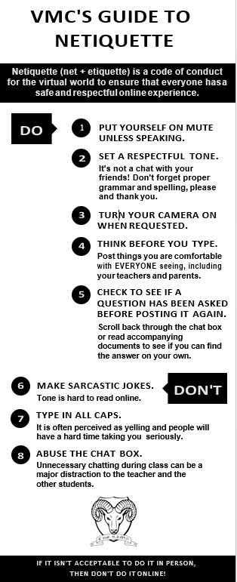

Information for parents and students 2022-2023 school year

Mission Statement

Mass Notification System

On-Line Educational Resources

Some Complementary Activities

Resources at your Fingertips

Nutrition and Food Services

Vocational Education Information

Registering for School Board Elections

MISSION STATEMENT
The mission of the English Montreal School Board is: “to support its schools and centres in their efforts to educate students within a caring, safe and inclusive learning community”. To fulfill its mission, the EMSB will:
- recognize and value the diversity of its community;
- provide all students with the opportunity to develop their talents and achieve their personal best;
- recognize the skills and competencies of its employees and support their ongoing professional development;
- encourage collaboration among the various educational partners;
- use resources effectively and innovatively to help schools and centres focus on the mission of instruction, socialization and qualifications;
- encourage lifelong learning and critical thinking.
MASS NOTIFICATION SYSTEM
The EMSB has currently in place an automated notification system. This system allows the EMSB to send information messages to your home, work, cell phone and email address. The system is used to communicate information such as school activities, special dates or events, emergency situations which include unexpected early dismissals, delayed school openings, school cancellation notices and others. The contact information must be updated to make sure that parents, guardians and students receive prompt and accurate delivery notifications. The system effectiveness relies on accurate information. Therefore the EMSB requires that parents, guardians and students provide up to date information on any and all telephone number(s) and email addresses available for parents and guardian(s). This information should be provided or updated on the Student Verification Form.
Inclement weather may disrupt bus transportation and regular school operations. This decision is usually made by 7:00 a.m. You may visit www.emsb.qc.ca or you may follow the EMSB on Twitter and Facebook or listen to any of the following radio stations for information: CJAD 800, Virgin Radio, CHOM, TheBeat925, TSN 690, CBC Radio-88.5FM, and Radio Canada-95.1FM.
You will receive one of the following messages:
  - Buses are cancelled: this message means that the schools remain open for students, but transportation services provided by the EMSB are cancelled for the area(s) affected. When buses are cancelled in the morning, they will not run in the afternoon. Some fully-bused schools are closed to students when buses are not running. Individual communities involved are aware of these schools.
  - The schools are closed. This message means that, due to bad weather conditions, schools are closed to students.
  - All schools and EMSB Head Office are closed. This message means that due to bad weather conditions, schools and board offices are closed to students and staff.

ONLINE EDUCATIONAL RESOURCES
VoD Zone
A collaboration between LEARN and La Société GRICS that offers over 5000 Streaming Discovery Education videos to students free of charge. Pictures, sounds and video clips can be incorporated into teacher or student productions. Access to the videos is done through a personalized LEARN user name and password, which in turns directs the user to their own personalized LEARN homepage.
Access is available from 5 p.m.-7 a.m.
For additional information, log on to www.learngrics.ca.

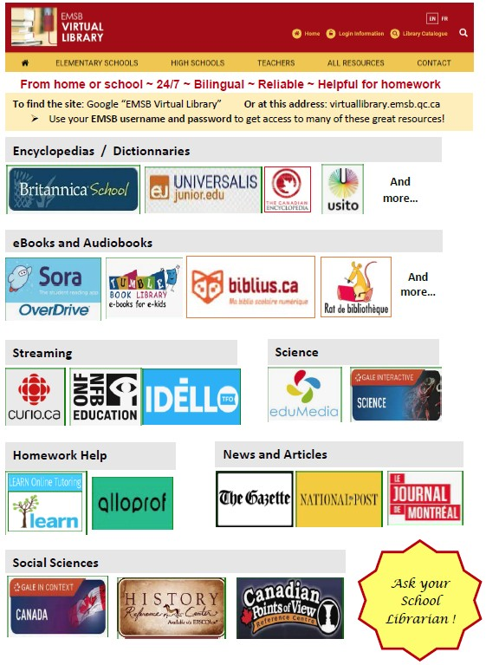
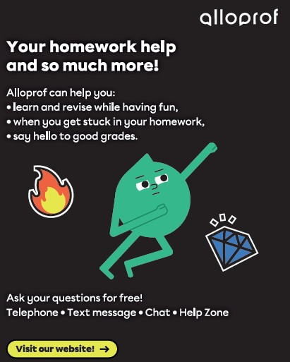
https://www.alloprof.qc.ca/en/students

Tel-jeunes
A free, confidential resource for young people throughout Quebec, available 24 hours a day, 7 days a week. Whether by telephone or via the Internet, professional counselors establish a relationship of trust with young people, answer their questions, and help them through whatever problems they are facing.
Tel: 514-288-1444 http://en.teljeunes.com/home

SOME COMPLEMENTARY ACTIVITIES

HOSPITAL OPPORTUNITY PROGRAM FOR
STUDENTS (HOPS) HOPS, a specific career exploration program, was designed to provide an opportunity for Secondary V students to gain “hands- on” experience in the various departments of a large hospital. The Program has enabled students to spend 1/2 day per week for two six-week periods in various departments of the hospital. Applications are available from your guidance counsellor. Interviews take place October and the program begins with an Orientation Session at the hospital at the end of October.

CAREER EXPLORATION PROGRAM: The
participation of over 800 companies where students are placed for one day in a profession or trade of their choice. They learn through observation, discussion and practical work. This program is offered to all Secondary IV and V students. Applications are available from your guidance counsellor in November. Visits to companies/ institutions take place between December and April.
HIGH SCHOOL CAREER FAIR – OCTOBER: The
EMSB hosts Career Fair at St. Pius X Career Centre, The main objective is to provide students with an in- depth exposure to the various educational opportunities available to them. The final day is devoted to Secondary IV students, providing them with an opportunity to start charting their respective futures two years in advance of graduation.

UNITED NATIONS UNIVERSAL CHILDREN’S DAY
- NOVEMBER 20th: Activities and programs organized by the spiritual community animators such as: Unicef projects, Toy Tea, Citizenship ceremonies, Black History Month, Veterans’ Week, etc. These activities are held to promote the ideas and objectives of the Charter of Children’s Rights and the welfare of Children throughout the world.
EMSB LIBRARY WEEK – JANUARY: Many activities are organized by EMSB librarians and library technicians to promote the excellent resources available in our libraries.
FAMILY LITERACY DAY – JANUARY 27th:
Workshops, special assemblies, library and class time with special guest readers are just a few of the events taking place during Family Literacy Day. It has become a memorable experience for all who have participated in the past and it has become part of the culture of many schools. (www.fld-jaf.ca)
TEACHER APPRECIATION WEEK – FEBRUARY:
This is the week designated by the Ministry of Education to thank and honor our dedicated teachers who work hard to provide students with a good education and a positive shared experience.
NUTRITION MONTH – MARCH: March is Nutrition month. Elementary school students in particular are sensitized to the importance of eating nutritiously. They also learn that a good breakfast every morning is necessary in order to maintain good health and to perform well in school.
INTERNATIONAL DAY FOR THE ELIMINATION OF RACIAL DISCRIMINATION - MARCH 20th: Many
EMSB high schools present special programming on this day with the objective of celebrating diversity, multiculturalism and mutual respect.

VOLUNTEER APPRECIATION EVENING – APRIL:
Parent volunteers perform valuable services in our schools. Each year, on the occasion of National Volunteer Week, a special gala event is held to pay tribute to them in helping us enhance the educational experience of their children.

HIGH SCHOOL PUBLIC SPEAKING CONTEST –
MAY: Secondary IV and V students compete in a public speaking contest. The Secondary IV Board winner will receive an all expenses paid week to Encounters with Canada in Ottawa and present his/her speech to the Women’s Canadian Club of Montreal. The Secondary V winner will go on to take part in the Rotary Club of Montreal Public Speaking Competition.
CHORALE GALA CONCERT – MAY: More than 75
students, representing 24 EMSB schools, participate in the EMSB choir known as the Chorale. The Chorale has had the opportunity to perform in all Montreal’s top concert venues. The choir regularly participates in exchanges with other choirs.

CRC AND JUNIOR ROBOTICS COMPETITION- The
CRC Robotics Secondary and CEGEP Competition integrates STEM competencies with visual arts, computer simulations, 3D and 2D animations, drama, web design, marketing and kiosk creation. It offers learning opportunities for STEAM-oriented, interested students. The enriching challenge of building a kiosk, large mechanic-based machine and programming a remote-controlled robot is the corner stone of the CRC event. At the same competition, the Junior Robotics competition for Elementary and Secondary students is held in conjunction with the CRC Robotics. The Junior competition incorporates mostly LEGO-based robots for its designated tasks. These two competitions are under the umbrella of the Québec based Educational Alliance for Science and Technology (EAST) organization. http://www.robo-crc.ca
FIRST® ROBOTICS- FIRST abbreviated, for Inspiration and Recognition of Science and Technology, is a robotics community that aims to prepare young people for future jobs through a suite of inclusive, team-based robotics programs for ages 4-18. These activities and competitions can be facilitated in school or in a structured afterschool program. Boosted by a global support system of educators, industries and sponsors that encompass a signature set of first core values to conduct research, fundraise, design, build, and showcase the teams’ achievements during annual competitions. these various competition categories are: Jr. FLL, FLL and FRC. FIRST has an interest on steam learning, interest, and skill-building well beyond high school. their international exposure and affiliations allow for participants to perform tasks encompassing the curriculum. It is regarded as a high-stakes competition and multi-faceted event. https://www.firstinspires.org

HYDRO-QUÉBEC MONTRÉAL REGIONAL SCIENCE
AND TECHNOLOGY FAIR - The Montréal Regional Science Fair is an event representing the English- speaking school communities within the Montréal regions, the greater Montréal, Lanaudière, Laurentides, Laval, Montérégie for Secondary and CEGEP students. On another day, an Elementary event is also available for the younger students. The post-Elementary event allows students to exhibit and present their scientific

innovations, experimentation and research ideas to judges and advocate it, for the general public. Some of the prize awards are monetary and opportunities for scientific recognition by industrial partners are viable. Following the Montréal Regional Science Fair, the awarded students from grades 9 – 12 have the opportunity to represent their country at the REGENERON INTERNATIONAL SCIENCE AND
ENGINEERING FAIR (formerly named Intel ISEF). This global Science Fair event is the world’s largest international pre-college science competition which provides an annual forum to approximately 1,800 Secondary students from 70 countries, regions, and territories to showcase their independent research. The yearly award winnings have been estimated to approximately $4 million. Information for the individual events can be found on this website. http://www.sciencetech.ca
RÉSEAU TECHNOSCIENCE- Le Réseau
Technoscience et ses organismes régionaux sont présents partout au Québec afin de promouvoir le goût des sciences et des technologies chez les jeunes Québécois de 4 à 20 ans. Leurs programmes et leurs activités encouragent l’émergence d’une relève scientifique tout en soutenant l’enseignement des sciences et des technologies par une approche concrète. Le Réseau Technoscience offre notamment les programmes suivants : Expo-sciences, Défis technologiques, les Animations Débrouillards et Les Innovateurs à l’école. Il assure également la diffusion de plusieurs trousses, publications et animations pédagogiques en science pour le primaire et le secondaire. https://technoscience.ca
ROBOCUP COMPETITION- ROBOCUP Canada is a
project-oriented educational initiative that supports local, regional and international robotics and artificial intelligent (AI) events from Elementary to post- university students. Each year, a published book is available with researcher’s findings. This worldwide organization is a community of sharing and provides students with opportunities to push the boundaries of AI. Each country organizes events, competitions and conferences to allow students with the opportunity to field test their robot designs and ideas. ROBOCUP allows students to use any type of robot system and materials, students wish to explore. Every robot is expected to be 100% autonomous and students are
allowed to use any programming language of choice. This robotics and AI organization embraces diversity, innovation and inventors. A variety of technologies are strongly encouraged so students can challenge the existing robots’ technologies and AI ideas to help humanity be a better place. ROBOCUP advocates the importance for robots and humans to live peacefully together. ROBOCUP is backed by a Federation of researchers, top industry innovators, developing University researchers and many other worldly industries. Even more, the International committees provide support through an online forum of exchanges and dialogue to help stretch the imagination. The Québec Canada committee organizes a qualifying event yearly for Elementary and Secondary students, while Canadian University students need to submit their robotics project online before they are accepted to compete at the world event each year. Local, national and International events are accessible. http://robocupcanada.ca
ZONE [01] ROBOTIQUE - ZONE01 s'est donné quatre principaux mandats qui concernent l'avancement de la robotique en éducation à travers le Canada avec la robotique LEGOs. Ces principaux mandats est de ; (1) Promouvoir l’éducation en sciences et technologie auprès des jeunes en créant des programmes de robotique pédagogique; (2) Soutenir les enseignants dans l’intégration de la robotique en classe par des programmes, outils et formations conçus pour leurs niveaux scolaires; (3) Promouvoir l’éducation en permettant aux jeunes, enseignants, chercheurs et autres acteurs en robotique pédagogique d’expérimenter avec les plates-formes robotiques et d’échanger entre eux; (4) Promouvoir l’éducation en soutenant l’organisation des compétitions de robotique et la participation des jeunes. ZONE01 Robotics est aussi l'organisateur national du WRO. La World Robot Olympiad (WRO) Canada est une compétition internationale de robotique qui rassemble des étudiants de la 5e année à l'université avec plus de 50 pays. Des équipes composées d’étudiants et assistées d'un coach développent leurs compétences pour résoudre des problèmes à travers des défis robotiques. À l'exception de la catégorie Advanced Robotics, les défis WRO sont aussi principalement résolu en utilisant des composants LEGO. https://www.zone01.ca

RESOURCES AT YOUR FINGERTIPSSCHOOL
GOVERNING BOARD (GB)

Every year the school holds an assembly of parents to elect representatives to the Governing Board which is made up of parents and school staff. The general assembly elects a delegate and alternate to the parents’ committee.

EMSB PARENTS’ COMMITTEE (EMSBPC) The
EMSBPC is composed of all delegates from all schools and a member of ACSES. The EMSBPC designates parents to various committees to the school board. The EMSBPC gives advice and makes recommendations. They elect four parent commissioners to sit at the Council of Commissioners.

ADVISORY COMMITTEE ON SPECIAL EDUCATION SERVICES (ACSES) ACSES advises
the School Board on issues which affect children who are learning disabled, intellectually handicapped, hearing and visually impaired,
physically handicapped or socially maladjusted.

PARENT PARTICIPATION ORGANIZATION (PPO)
HOME & SCHOOL (H&S) The groups promote parental involvement through volunteering, fundraising and school activities.

ENGLISH MONTREAL STUDENT ADVISORY
COMMITTEE (EMSAC) Composed of students from high schools, this committee links the students and the Council of Commissioners for discussion on common issues. The committee allows the students to develop necessary leadership skills needed to become future leaders in our community, the business world and beyond.
For more information visit the parent info tab at

www.emsb.qc.ca
QUESTIONS OR CONCERNS
Step 1 Talk to your child’s teachers
Teachers are one of your most important sources of

information. They know your child and can provide valuable information.

Step 2 Talk to your principal
Principals are another important resource that can address any questions you may have.

Step 3 Talk to your Sector Director
They are another important resource that can help you with any concerns or questions.

Step 4 Visit the Websites www.emsb.qc.ca
WHOM DO I CALL?
Administration Building 514-483-7200 Not sure whom to call 0 for reception Director General #7262 Assistant Director General Admin. #7227 Assistant Director General Educ. #7232 Sector Director Elementary #7239
Sector Director Secondary #7624

Secretary General
Procedures, access to info #7264 Governing Boards, Parents Committee #7242

School Organization
Eligibility #7248 #7250
Daycare #7518
Transportation #7255
Communications website, media #7245

Educational Services
Summer school, exams, curriculum #7355

Student Services
Derogations, Guidance, special needs #7309 Adult Ed and Vocational Services #7449 Adult Ed and Vocational Info line
514-488-4636

OTHER RESSOURCES
Ministère de l’Éducation du Québec http://www.education.gouv.qc.ca/en/home/ Student Ombudsman 514-483-7200 ext. 7880 studentombudsman@emsb.qc.ca

E.P.C.A.-English Parents’ Committee Association
https://epcaquebec.org/ info@epcaquebec.org

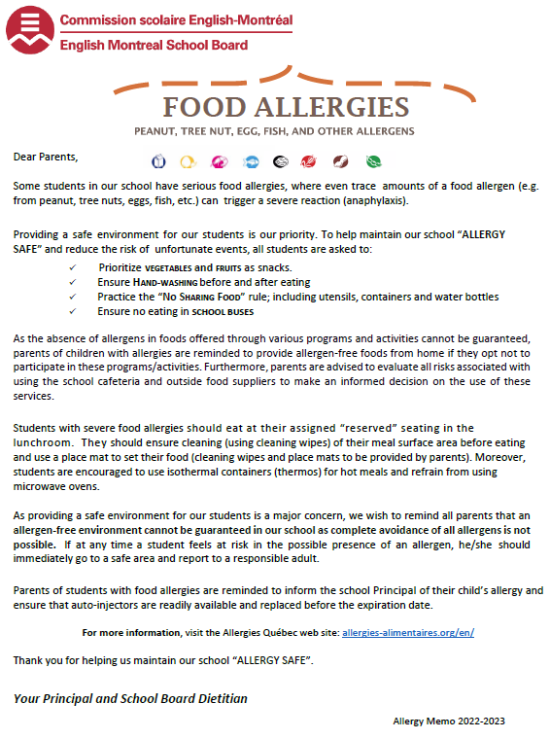

Promoting Healthy Eating at School Eat a variety of healthy foods every day
Canada’s food guide
Health Canada released Canada’s new food guide in January 2019
The English Montreal School Board Nutrition Policy aims at promoting healthy lifestyle habits through nutritious food choices and physical activity. Feeding the body and mind daily with nutritious foods benefits healthy growth and academic success! For more information on the Nutrition Policy, visit the Nutrition and Food Services website at www.emsb.qc.ca/emsb/services/support-services/nutrition

Make water your drink
Have plenty of vegetables and fruits

Eat protein foods

of choice Choose whole
grain foods
Tips to stay hydrated with water
- Pack and carry a reusable water bottle
- Drink water at meal and snack time
- For flavor, add fruit or herbs to water (e.g. mint, strawberries, pear …)
- If you like fizz, try carbonated water
- Drink water during and after playing sports or being active
What about milk?
- Milk and dairy products are now considered protein foods
- They remain an important source of vitamin D and calcium, especially for children
- Milk is also a source of hydration
Key messages
  - The Eat Well Plate allows you to easily see how to create a balanced meal. At every meal, aim to fill ½ your plate with vegetables and fruits, ¼ protein foods and ¼ whole grain foods. Eating a variety of foods provide various nutrients needed to grow, learn and be healthy.
  - Examples of protein foods include legumes, nuts, seeds, tofu, fortified soy beverage, fish, shellfish, eggs, poultry, lean red meat, lower fat dairy products such as milk, yogurt, kefir, and cheese.
  - Healthy eating goes beyond the foods on your plate. Being mindful of your eating habits, cooking more often, enjoying your food and eating meals with others are all important parts of healthy eating.
  - Being mindful of your eating habits includes being aware of and eating according to your feelings of hunger and fullness. As children can become full quickly, snacks are important to ensure they are meeting their nutritional needs.
For more information, visit Health Canada’s website: https://food-guide.canada.ca/en/

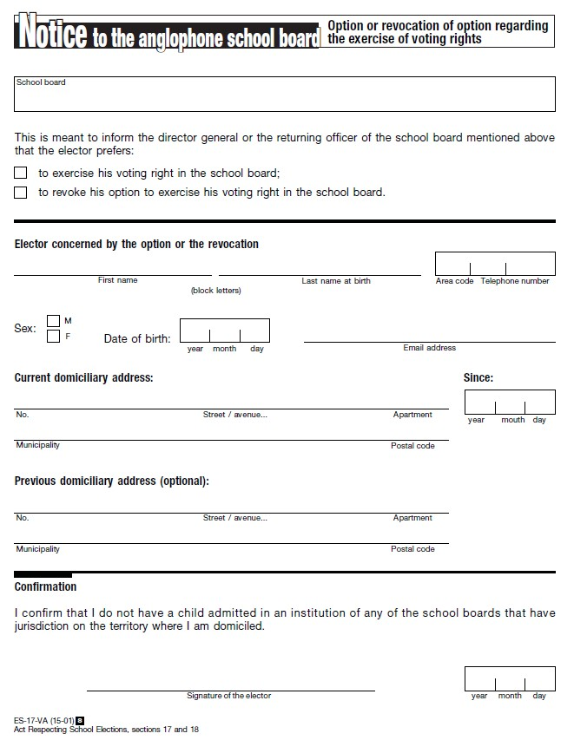

This form can also be accessed on the EMSB website: https://www.emsb.qc.ca/emsb/about/governance/elections/voting-rights

