Hello Everyone,
We are extremely excited to announce that the VMC hockey program will be returning for the 2021-2022 school year!
There have been a lot of exciting changes and additions to school hockey in Quebec along with new and exciting features
within our own program. The VMC Governing Board has approved the program at the meeting held June 14, 2021.
If you are interested having your child join the hockey program for next year, please fill out the attached questionnaire. There is a cost for taking part and information will be shared at the meeting.
Once we receive all the questionnaires, we will be holding a meeting to discuss the program and afterwards we will confirm the teams.
If you have any questions, please contact Nick Romano at 514 882 4840 or info.groupe71@gmail.com
Link for Questionnaire : https://forms.gle/4NU86cUUnhihkj2X7

Thank you,
Nick Romano


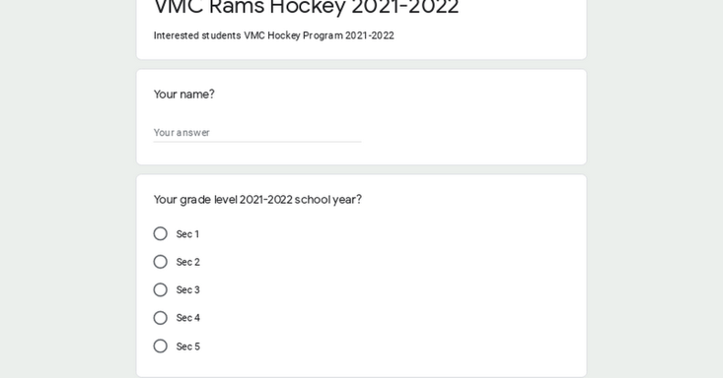 | VMC Rams Hockey 2021-2022  Interested students VMC Hockey Program 2021-2022  forms.gle

