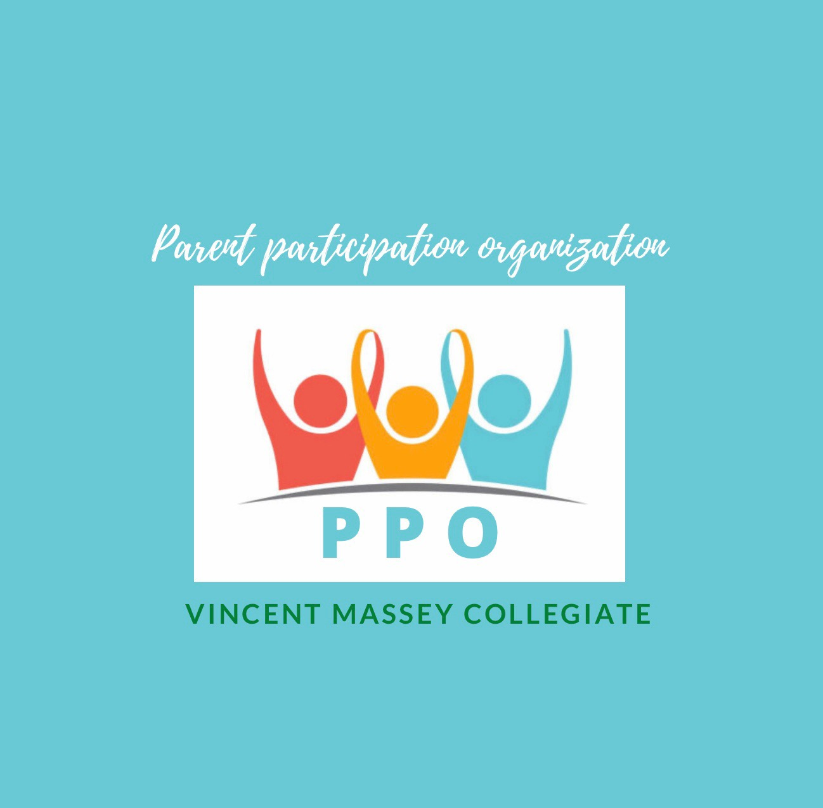
Dear VMC Families:
On behalf of your PPO (Parent Participation Organization) volunteers, I wish you an infinitely improved 2021.
Now in our 4th year, the VMC PPO is comprised of dedicated and involved parents who, with the assistance of our Principal and Vice-Principals, help cultivate our VMC community with an eye to fostering our children’s success.
Our focus is on, among other things, the development of School Community Spirit Activities. To that end, past events included our welcome-back BBQ, Comedy Night, Bingo-plus night, and our very popular gently-used VMC uniform drive.
Although Covid has curtailed our in-person activities, your PPO continues to meet regularly, but virtually, to continue our contributions to our VMC environment.
The results of these meetings, which include an invitation to our upcoming Trivia Night and the introduction of our PPO Community Action Award, are detailed below.
We look forward to meeting you at TRIVIA NIGHT!
Want to join PPO? Please email me at vmcgb@hotmail.com .
Best wishes for a healthy and successful semester.
Robert Soroka
Chair – VMC PPO
Chair – VMC Governing Board
Mark Your Calendar for our next School Community Spirit Activity: our VMC ONLINE TRIVIA NIGHT - Friday, February 5th at 7:30 pm
How about a curfew-friendly activity where you and your entire family can meet other VMC families virtually while testing your trivia skills.
VMC PPO has partnered with NOJO Trivia (profiled on City News, The Gazette, and CJAD) to produce a fun-filled event. Create your own team of up to 8 people or let us place you in a mixed team of other VMC parents or students (you let us know!) Watch for our next email in the coming week for more details!
For more information, email vmcgb@hotmail.com .
NEW PPO Community Action Award for a Sec 5 Graduate !
The inaugural VMC Community Action Award will be presented to a deserving VMC graduating student at our 2021 VMC Convocation, recognizing the qualities and character that embody the community spirit of the PPO.
The award will be presented to the student who, by virtue of volunteerism, activism, organization of community-based events, or other like activities, whether within or external to the VMC community, has contributed to effecting positive change while a student at any time between Sec I and Sec V.
Sec V students can self-nominate or be nominated. Once nominated, students will be sent an application package.
To self-nominate or to nominate another student, send an email that includes:
nominee’s name
nominee’s email address
nominee’s phone number (optional)
Nominations must be made by no later than April 30, 2021, at 23:59.

REMINDER: LAST CHANCE: VMC Athletic Clothes and Hats
Hoodies branded with the VMC logo, as well as athletic pants, winter hats and summer caps are still available to purchase.
With the sale of each hoodie, $5.00 is directed to the PPO to fund VMC community-based projects.
Order your hoodie by the EXTENDED deadline: January 18, 2021
www.evangelistasports.com/vmc

